Each video contains 900 frames and is 30 seconds long. We stabilize each frame in 33 strips.

For the horizontal shifts we have this scalogram:

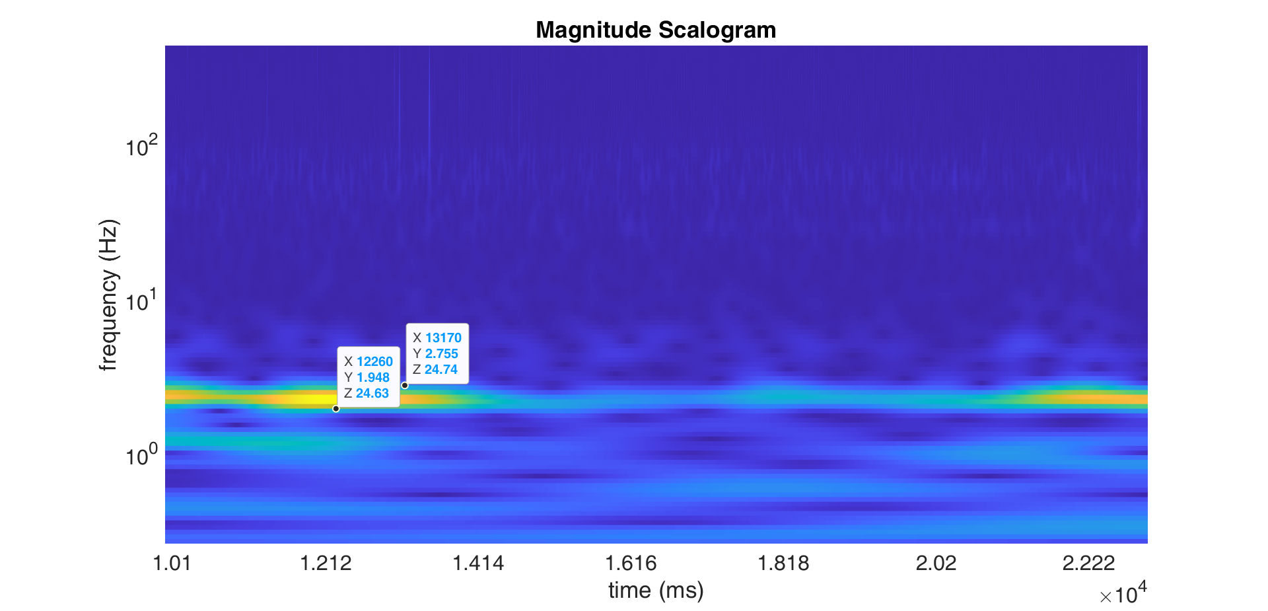

Figure 1- scalogram of the horizontal shift.

And for the vertical shifts we have this scalogram:

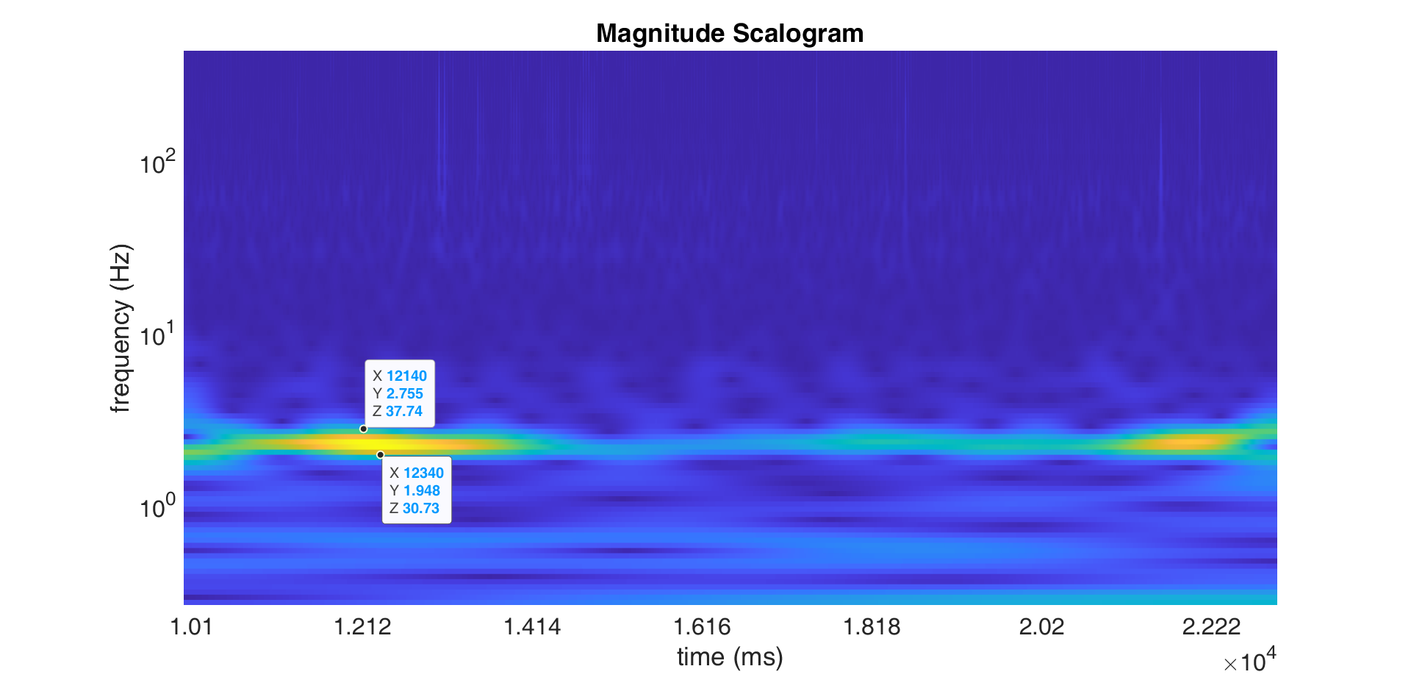

Figure 2- scalogram of the vertical shift.

As we can see in Figure 1 and Figure 2, that high-power component corresponds around the frequency 2 to 2.75 Hz.

We can check it on the x and y plots.



Figure 3- horizontal (red), and vertical (blue) shifts through time.

As we can see in this figure two successive negative peaks happened at 13520 ms and 13920 ms. Therefore, the frequency will be:

Which is in accordance with what we found in scalograms. But, we should keep this in mind that this dominant frequency changes over time.

Now, based on your explanations, we have two options for finding that repetitive pattern. In both options we have to first find the carrier signal.

**Option1 (finding carrier signal based on the frequency):**

I removed components with frequency higher than 3 Hz. Here are the scalograms for horizontal and vertical shifts after removing high-frequency components.

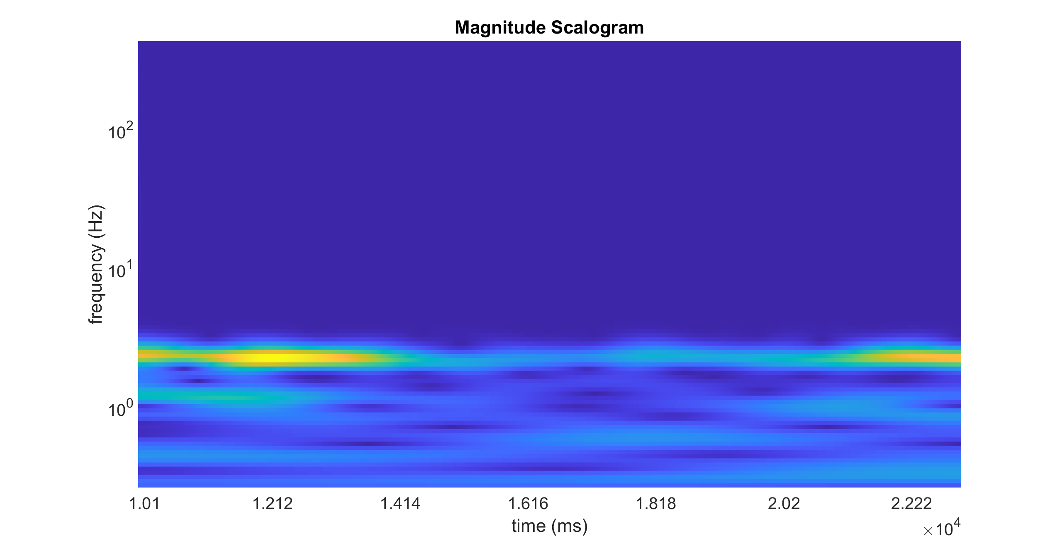

Figure 4- scalogram of horizontal shift after removing high-frequency components.

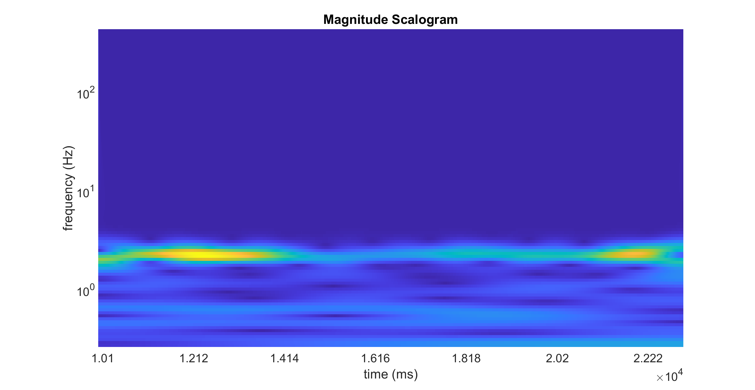

Figure 5- scalogram of vertical shift after removing high-frequency components.

And here are the horizontal and vertical shifts before removing high-frequency components (blue) and after removing (red).





Figure 6- up: horizontal shifts before removing high-frequency components (blue) and after removing (red) them. down: the same for vertical shifts.

The problem is that although scalogram gives a good vision about the distribution of frequency components through time, it doesn’t give good results when we remove some components globally. It seems that I had to remove the frequency components in a moving temporal window. But, instead of this I thought it is better to try Fourier transform first, maybe we can remove some frequency components globally.

For horizontal shifts:



Figure 7- absolute value of the Fourier transform for horizontal shifts.

I zoomed in this figure to see what is going on around the frequency=30 Hz. As we can see in Figure 8, against our expectation, there is no significant component at 33 Hz. There is a component a little significant at 30.31 Hz. But, even this component is really small compared to the low-frequency components.



Figure 8- absolute value of the Fourier transform for horizontal shifts zoomed around 30 Hz.

Here is the zoomed plot around the low-frequency components. I think that component in 2.308 Hz is the component that we were looking for (the swirl). And it is in accordance with what we found in the scalogram of Figure 1.



Figure 9- absolute value of the Fourier transform for horizontal shifts zoomed around low-frequencies.

Before removing unwanted frequency components, I first show the results of the Fourier transform for the vertical shifts.



Figure 10- absolute value of the Fourier transform for vertical shifts.

Zooming in around the frequency= 30 Hz:



Figure 11- absolute value of the Fourier transform for vertical shifts zoomed around 30 Hz.

Again that component happens at 30.31 Hz.

And if we zoom in around the low frequencies:



Figure 12- absolute value of the Fourier transform for vertical shifts zoomed around low-frequencies.

Again, there is a strong component at 2.308 Hz.

Based on all these observations, I think the frequency of the swirl is 2.308 Hz. Also, the frequency of the pattern that we were looking for is 30.31 Hz.

I remove the low frequency components to extract that pattern. First, these are the comparisons between the original signals and low-frequency components:





Figure 13- up: riginal horizontal shifts before removing high-frequency components (red) and after removing (red) them. down: the same for vertical shifts.

The remaining components of horizontal and vertical shifts (after removing low-frequency components) are:





Figure 14

Now, we can check the component at 30.31 Hz.



Figure 15- high frequency components of horizontal shifts broken into 33-strip windows and stacked.

After removing outliers:  


Figure 16- high frequency components of horizontal shifts broken into 33-strip windows and stacked (outliers in Figure 15 removed)

I think still I can’t see any pattern common in all the signal length. For example, for the first 10 strips:



Figure 17- first ten high frequency components of horizontal shifts broken into 33-strip. (outliers in Figure 15 removed).

I thought maybe removing low-frequency components is not a good option to reveal this repetitive pattern. So, I went for the second option:

**Option2 (finding carrier signal using MATLAB built-in functions for smoothing):**

I know that these functions also filter high-frequencies. But still, maybe the way that they remove high frequencies is different from what I did. So, it is worth testing.





Figure 18- up: riginal horizontal shifts before removing high-frequency components (red) and after removing (red) them with matlab built-in function. down: the same for vertical shifts.

Here I stacked cropped signals after smoothing signal:



Figure 19- high frequency components of horizontal shifts broken into 33-strip windows and stacked.

Comparing to Figure 15, I don’t see significant difference. And if we remove outliers, we obtain the following image, which is again similar to Figure 16.



Figure 20- high frequency components of horizontal shifts broken into 33-strip windows and stacked (outliers in Figure 15 removed)

Based on Figure 8 and Figure 11, I was expecting something on 30.31 Hz. However, it seems we don’t have a repetitive pattern on this frequency all the signal long.

The last thing that I did, was just taking a closer look to Figure 1 and Figure 2. Since low-frequency components are bold in these two figures, we can’t see well what is going on at 30.31 Hz. So, I removed low-frequency components, and plotted scalogram again.

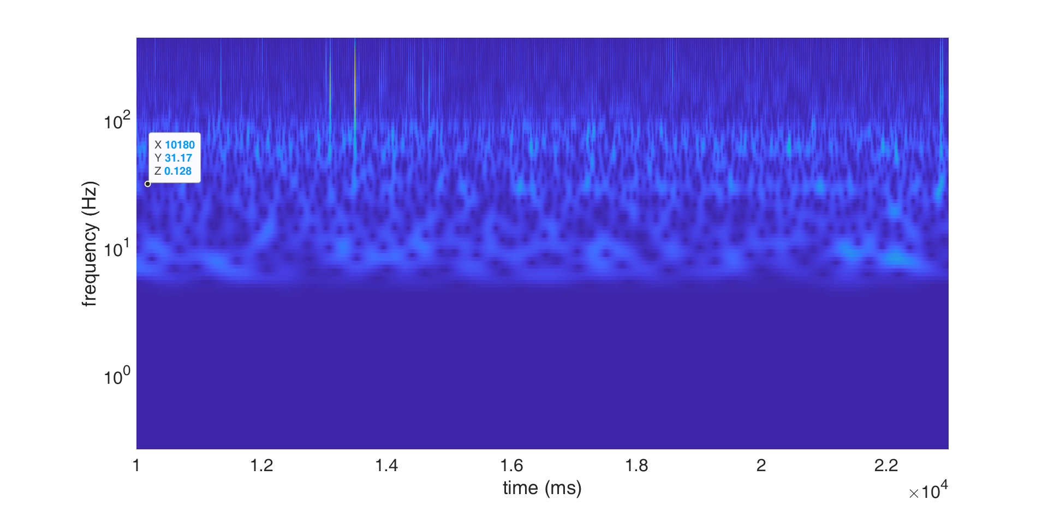

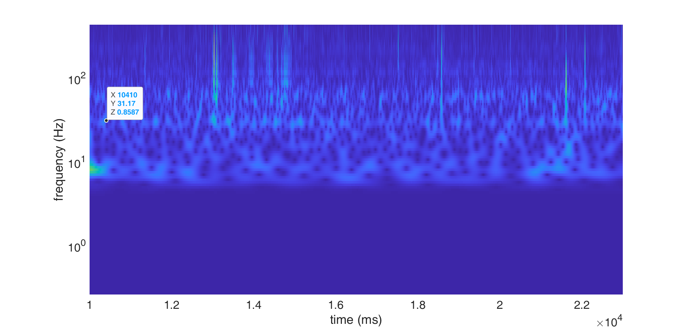

Figure 21- up: scalogram of the horizontal shifts after removing low-frequency components. Down: the same for vertical shifts.

I put an indicator on Figure 21, both for horizontal (Figure 21-up) and vertical (Figure 21-low) shifts. As we can see in this figure, that component at 30.31Hz is not available all the time.

Finally, if we remove all the high frequency components and only keep components in Figure 9 and Figure 12, we will have the following x-y plot:

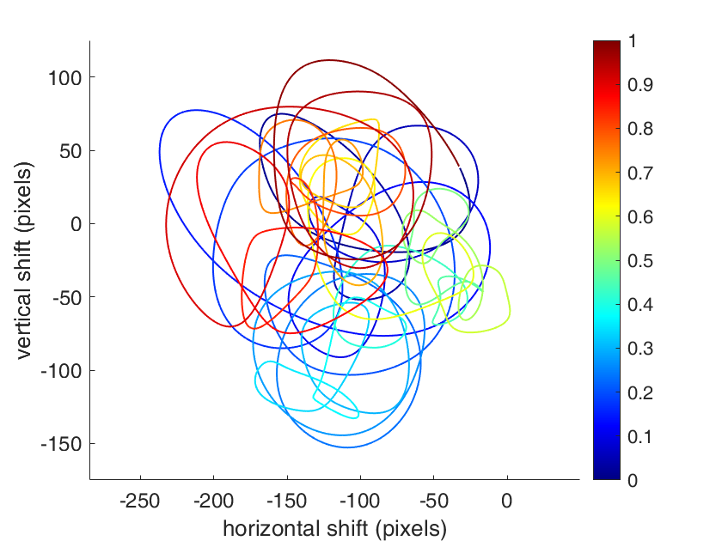

Figure 22-x-y plot for the swirl after removing high-frequency components.